

**FITFLEX : YOUR PERSONAL FITNESS COMPANION**

**TEAM ID :NM2025TMID40140**

**TEAM DETAILS:**

**Team ID :** **NM2025TMID40140**

**Project Title : FITFLEX : YOUR PERSONAL FITNESS COMPANION**

**Team Leader :** **Sooriya A**

**NM Id:** 1377B3DB9A3BF03AD4042EF2EDBDB5

**Team member :** **Rakesh S**

**NM Id:** 2B048FB3491E2A790AB441EF2F4D275

**Team member :** **Udhaya Narayanan M**

**NM Id:** A802C36EF26499D4BDA241153C88C

**Team member :** **Kamesh A**

**NM Id:** 61B8D0D79456D5B5D6B5A496CCB31

**Objective:**

The aim of this project is to build a fitness companion assistant that helps users workout, burnout calories and make slime & healthy .

**Key Points:**

* **Personalized Workouts**: Tailors fitness plans based on user goals and activity levels.
* **Real-Time Tracking**: Monitors progress with timers, progress bars, and reset logic
* **User-Friendly Interface**: Clean UI with intuitive controls for seamless navigation.
* **Secure Data Management**: Handles user details (ID, name, email) safely and efficiently.
* **Built with Modern Tech**: Uses React, TypeScript, and Node.js for fast, scalable performance.
* **Cloud Integration**: Supports remote access and data syncing via cloud services.
* **Expandable Design**: Easily adaptable for new features like nutrition tracking or social sharing.

**Platform & Technology Used :**

The project is developed as a web-based application to ensure accessibility and ease of use across devices with a modern browser. The following technologies and platforms are used:

• React: A powerful JavaScript library for building interactive and component-based user interfaces.

• HTML5: Used for structuring the web pages and defining the content of the application.

• CSS3: Utilized for styling and designing a responsive, user-friendly, and visually appealing interface.

• JavaScript (ES6+): The core programming language used for implementing business logic, interactivity, and communication between components.

• Git: A version control system used for managing code, tracking changes, and maintaining project versions effecitively

**Implementation/Process:**

1. Home Page

* Displays featured workouts, recent activity, and motivational highlights.
* Acts as the main entry point for users to access their fitness dashboard.

2. Workout Search

* Users can search workouts by name, type (cardio, strength, yoga), or duration.
* Quick filters for beginner, intermediate, and advanced levels.

3. Workout Details

* Each workout includes steps, required equipment, estimated time, and calorie burn.
* Presented in a clean, readable format for easy follow-along.

4. Smart Suggestions

* Users can input available equipment or fitness goals.
* The system recommends suitable workouts tailored to their setup.

5. Favorites & Personalization

* Option to bookmark or save favorite workouts.
* Personalized workout suggestions based on user history and preferences.

6. User-Friendly Interface

* Responsive design optimized for both mobile and desktop use.
* Smooth navigation across workout categories, progress tracking, and settings.

7. Testing & Deployment

* The app is thoroughly tested for bugs, performance, and usability.
* Deployed online with secure access and cloud-based data syncing.

**OUTPUT/RESULT:**

**Project structure**:

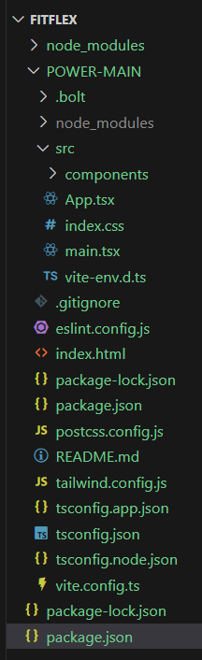

**FITFLEX HOMEPAGE:**

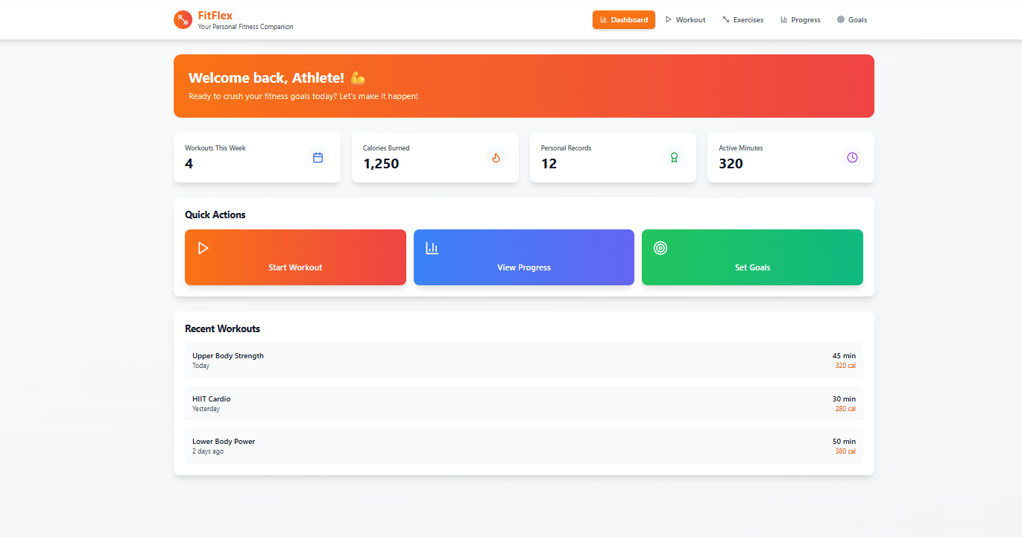

WORKOUT PAGE:

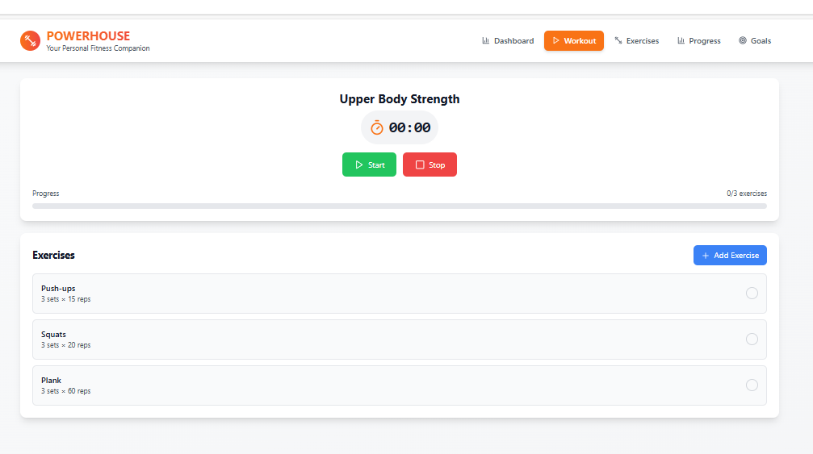

**EXERCISE PAGE:**

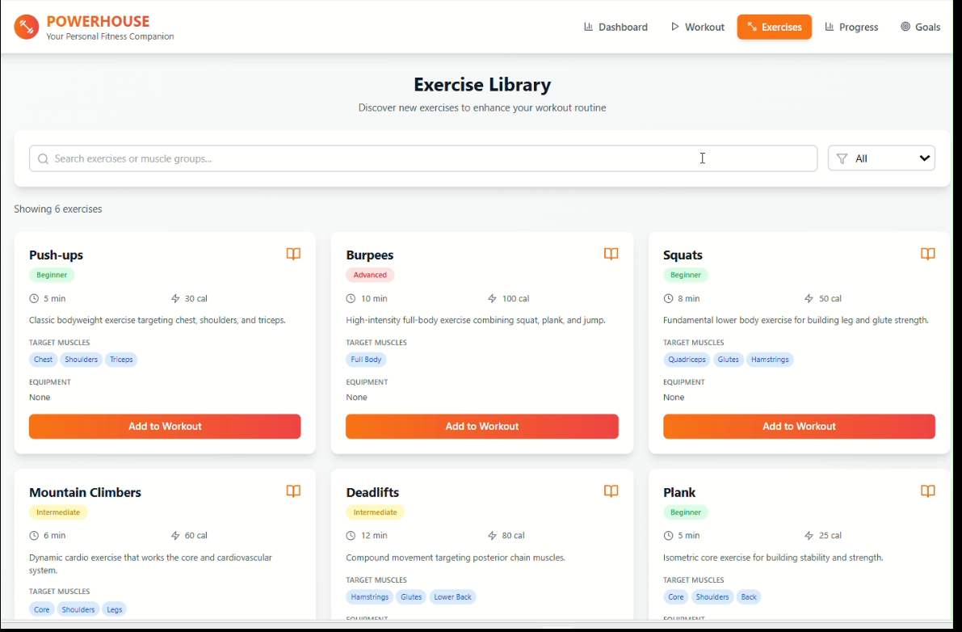

PROGRESS PAGE: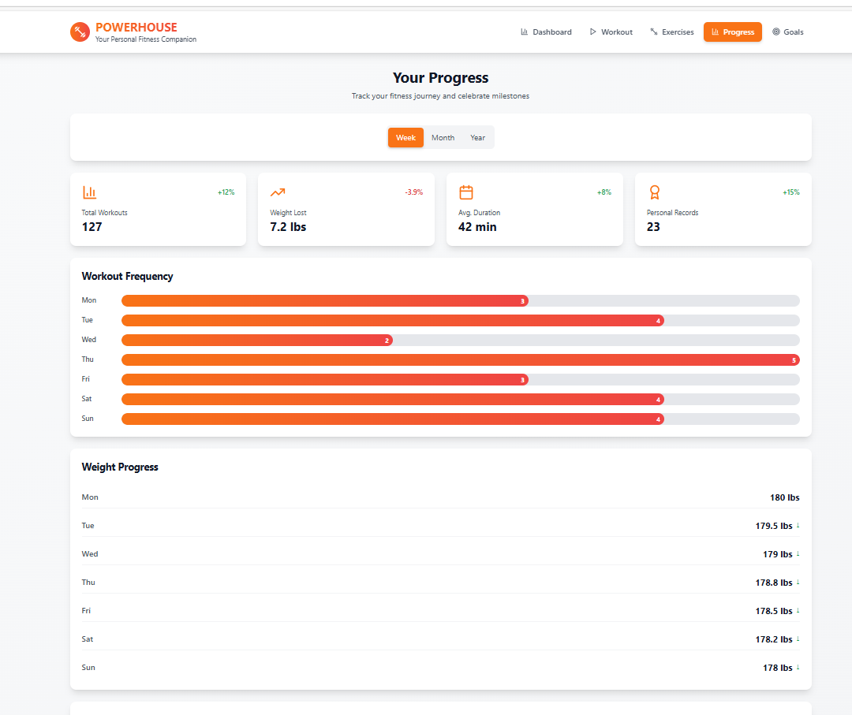

GOALS PAGE:

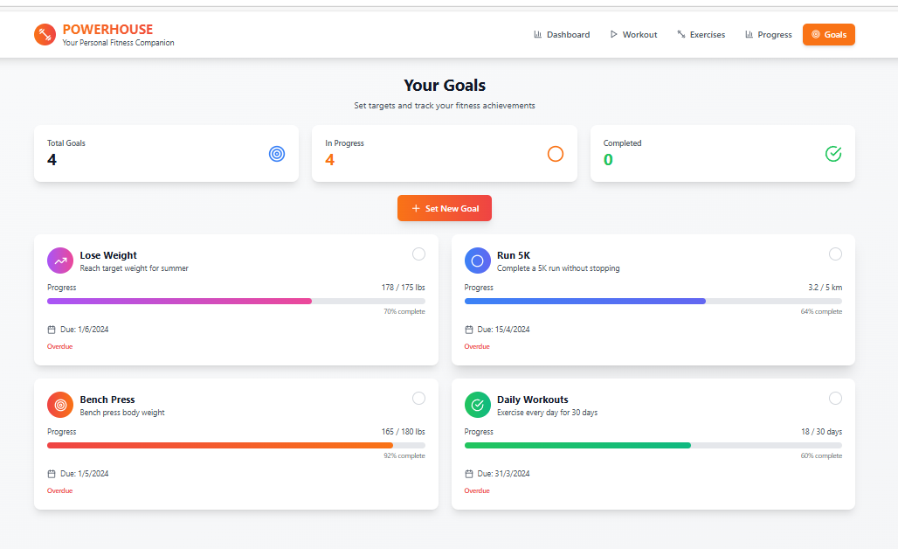

**Upcoming Enhancements:**

1. **Smart Workout Recommendations**

* AI-driven suggestions based on your goals, progress, and preferences
* Adaptive routines that evolve with your performance

2. **Advanced Progress Analytics**

* Weekly and monthly insights with visual graphs
* Compare performance across workouts and track consistency

3. **Social & Community Features**

* Join challenges with friends or global users
* Share achievements and earn badges for milestones

4. **Voice-Controlled Workout Mode**

* Hands-free navigation during workouts
* Real-time audio cues for sets, rest, and motivation

5. **Custom Timer & Interval Builder**

* Design your own HIIT, Tabata, or circuit timers
* Save and reuse custom intervals for different workouts

6. **Nutrition & Recovery Integration**

* Log meals and hydration
* Track sleep and recovery to optimize performance

7. **Gamified Experience**

* Level up with XP points for consistency
* Unlock new themes, avatars, and workout modes

8. **Offline Mode**

* Access your saved workouts without internet
* Sync progress once you're back online